CHELSEA PRIMARY SCHOOL- PURPOSE, VISION AND VALUES
_____________________________________________________________________________________________________________________________________
PURPOSE
Chelsea Primary School is a learning community working cooperatively to prepare students for an ever changing world.
Chelsea Primary School provides the opportunity for students to achieve personal excellence by developing their academic, social, physical and creative potential. We aim to prepare our students for the future by developing clear thinkers and decision makers who are active and effective citizens in their local and global community.
OUR VISION
Our vision is to create a passionate learning community that inspires, challenges and supports all students to achieve to their full potential.
Our school promotes connectedness, through the building of positive relationships and mutual respect, as we share our cultural backgrounds and celebrate our diversity within a supportive school-wide atmosphere. We pride ourselves on enabling each student to develop a sense of belonging; to make contributions and be valued as individuals.
Our students are encouraged to take responsibility for striving to achieve their best, seeking answers through curiosity and demonstrating resilience by welcoming challenges and learning from mistakes. We place particular emphasis on our professional and highly motivated staff, in partnership with parents and the wider community, being actively involved in our students' learning and interest in this lifelong process.
We support and promote the principles and practices of Australian Democracy in its educational programs and policies. Specifically, we are committed to:
*elected Government *freedom of religion
*the rule of law *equal rights for all before the law
*freedom of speech and association *the values of openness and tolerance

SCHOOL VALUES
Chelsea Primary School’s core values are; Relationships, Respect, Responsibility, and Resilience. These values were developed in consultation with teachers, students and parents.
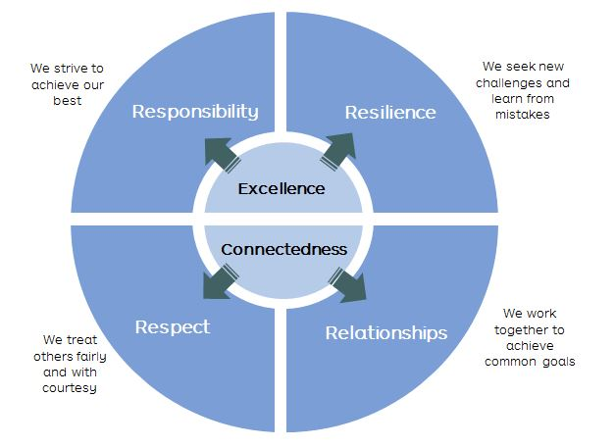

At the beginning of each year students focus on our four values and develop their understanding of behaviours which support effective learning. Students are actively involved in the development of their class manifestos, norms and expectations which reflect our values and showcase them to the community.
Regular evaluation processes will be in place to measure performance in all areas of the school with respect to the implementation of the vision and values of the school.

Evaluation | To be reviewed as part of the Education Sub Committee three yearly minor policy review cycle
Date Ratified | November 2018
Next review date | November 2021
Related policies | Child Safety Policy Statement  Child protection And Mandatory Reporting Policy  Chelsea Primary School-Purpose, Vision and Values  Child Safety Code of Conduct-Staff, Visitors and School Council Members
Related Documents
Resources

